NAME: S.KARUNYA
REG.NO: 2503917773822046

C++ PROGRAMS(ASSIGNMENT):
->EXCEPTION HANDLING:
1.ODD OR EVEN:
#include<iostream>
using namespace std;
int main()
{
int x;
cin>>x;
try
{
if(x%2!=0)
{
throw -1;
}
cout<<"Even number!";
}
catch(int e)
{
cout<<"Odd number caught!";
}
return 0;
}

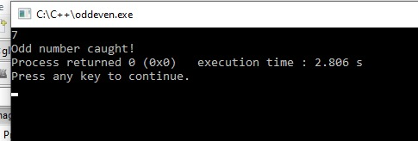
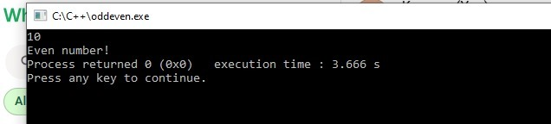

2.VOTING ELIGIBILITY:
#include<iostream>
using namespace std;
int main()
{
int age;
cin>>age;
try
{
if(age<18)
{
throw "Not eligible to vote!";
}
cout<<"Eligible to vote!";
}
catch(const char* msg)
{
cout<<"Exception : "<<msg<<endl;
}
return 0;
}

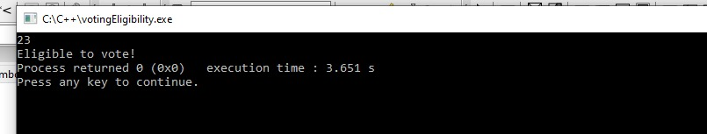
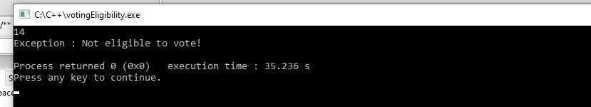

3.STOCK MANAGEMENT:
#include<iostream>
using namespace std;
class OutofStockException
{
public:
void displayMessage()
{
cout<<"Error : Requested quantity exceeds available stock!"<<endl;
}
};
class Product
{
private:
int stock;
public:
Product(int s)
{
stock=s;
}
void purchase(int quantity)
{
if(quantity>stock)
{
throw OutofStockException();
}
else
{
stock-=quantity;
cout<<"Purchase successful!";
cout<<"Remaining stock : "<<stock<<endl;
}
}
};
int main()
{
int availableStock,requestedQty;
cout<<"Enter available stock : ";
cin>>availableStock;
cout<<"Enter requested quantity : ";
cin>>requestedQty;
Product p(availableStock);
try
{
p.purchase(requestedQty);
}
catch(OutofStockException e)
{
e.displayMessage();
}
}

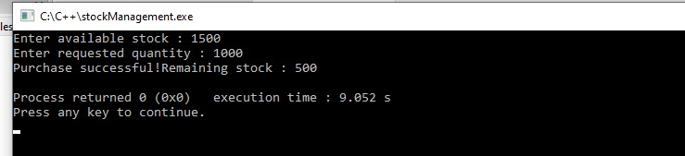
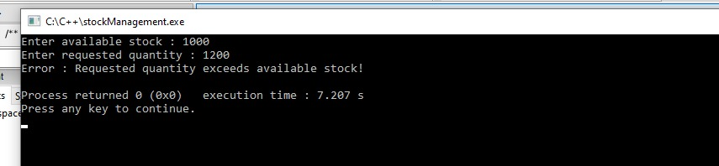

4.MOVIE TICKET:

#include<iostream>
using namespace std;
class HouseFullException
{
public:
void message()
{
cout<<"Exception : House is FULL!"<<endl;
}
};
class NoBookingException
{
public:
void message()
{
cout<<"Exception : No tickets booked!"<<endl;
}
};
class MovieTicket
{
int capacity;
int booked;
public:
MovieTicket(int cap)
{
capacity=cap;
booked=0;
}
void bookTicket()
{
if(booked==capacity)
throw HouseFullException();
booked++;
cout<<"Ticket Booked.Total Booked : "<<booked<<endl;
}
void cancelTicket()
{
if(booked==0)
throw NoBookingException();
booked--;
cout<<"Ticket Cancelled.Total Booked : "<<booked<<endl;
}
void display()
{
cout<<"Available Seats : "<<(capacity - booked)<<endl;
}
};
int main()
{
MovieTicket m(5);
int choice;
while(true)
{
cout<<"\n1.Book Ticket\n2.Cancel Ticket\n3.Display\n4.Exit\n";
cout<<"Enter choice : ";
cin>>choice;
try
{
switch(choice)
{
case 1:
m.bookTicket();
break;
case 2:
m.cancelTicket();
break;
case 3:
m.display();
break;
case 4:
return 0;
default:
cout<<"Invalid choice!"<<endl;
}
}
catch(HouseFullException e)
{
e.message();
}
catch(NoBookingException e)
{
e.message();
}
}
}

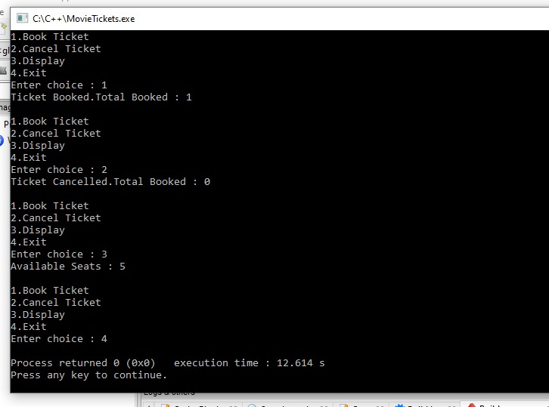

5.PARKING:

#include<iostream>
using namespace std;
class ParkingFullException
{
public:
void message()
{
cout<<"Exception : Parking is FULL!"<<endl;
}
};
class ParkingEmptyException
{
public:
void message()
{
cout<<"Exception : Parking is EMPTY!"<<endl;
}
};
class ParkingLot
{
int capacity;
int vehicles;
public:
ParkingLot(int cap)
{
capacity=cap;
vehicles=0;
}
void parkVehicle()
{
if(vehicles==capacity)
throw ParkingFullException();
vehicles++;
cout<<"Vehicle Parked.Total Vehicles : "<<vehicles<<endl;
}
void removeVehicle()
{
if(vehicles==0)
throw ParkingEmptyException();
vehicles--;
cout<<"Vehicle Removed.Total Vehicles : "<<vehicles<<endl;
}
void display()
{
cout<<"Available Slots : "<<(capacity - vehicles)<<endl;
}
};
int main()
{
ParkingLot p(5);
int choice;
while(true)
{
cout<<"\n1.Park Vehicle\n2.Remove Vehicle\n3.Display\n4.Exit\n";
cout<<"Enter choice : ";
cin>>choice;
try
{
switch(choice)
{
case 1:
p.parkVehicle();
break;
case 2:
p.removeVehicle();
break;
case 3:
p.display();
break;
case 4:
return 0;
default:
cout<<"Invalid choice!"<<endl;
}
}
catch(ParkingFullException e)
{
e.message();
}
catch(ParkingEmptyException e)
{
e.message();
}
}
}

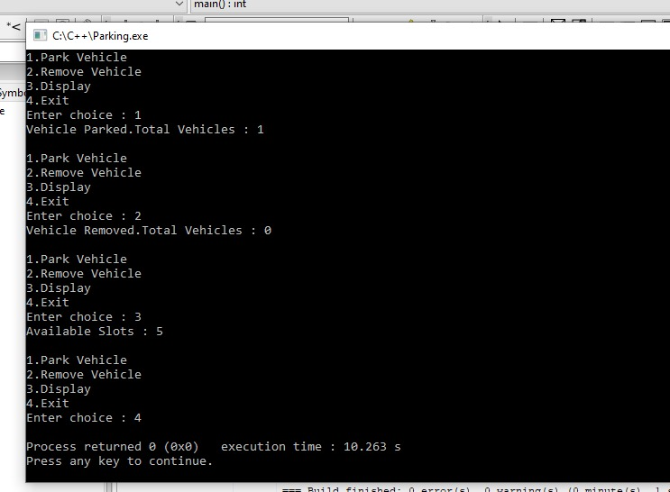

6.ATM:

#include<iostream>
using namespace std;

class InvalidPIN
{
public:
void message()
{
cout<<"Exception: Invalid PIN!"<<endl;
}
};

class InsufficientBalance
{
public:
void message()
{
cout<<"Exception: Insufficient Balance!"<<endl;
}
};

class ATM
{
int pin = 1234;
float balance = 5000;

public:
void access(int enteredPin)
{
if(enteredPin != pin)
throw InvalidPIN();
}

void withdraw(float amt)
{
if(amt > balance)
throw InsufficientBalance();

balance -= amt;
cout<<"Withdrawn: "<<amt<<endl;
cout<<"Remaining Balance: "<<balance<<endl;
}
};

int main()
{
ATM a;
int pin;
float amount;

cout<<"Enter PIN: ";
cin>>pin;

try
{
a.access(pin);

cout<<"Enter amount: ";
cin>>amount;

a.withdraw(amount);
}
catch(InvalidPIN e)
{
e.message();
}
catch(InsufficientBalance e)
{
e.message();
}

return 0;
}

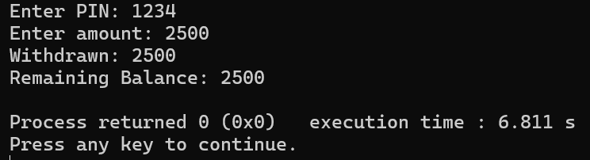
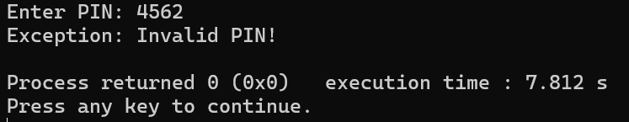
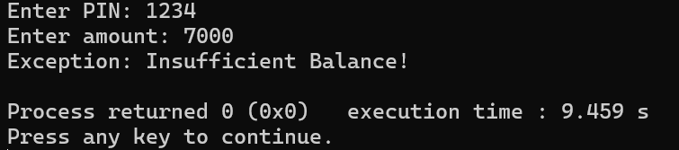

7.ARRAY PROCESSING:
#include<iostream>
using namespace std;

class IndexError
{
public:
void message()
{
cout<<"Exception: Invalid Index!"<<endl;
}
};

class NegativeNumber
{
public:
void message()
{
cout<<"Exception: Negative numbers not allowed!"<<endl;
}
};

int main()
{
int arr[5] = {10, 20, 30, 40, 50};
int index, divisor;

cout<<"Enter index (0-4): ";
cin>>index;

cout<<"Enter divisor: ";
cin>>divisor;

try
{
if(index < 0 || index >= 5)
throw IndexError();

if(divisor < 0)
throw NegativeNumber();

if(divisor == 0)
throw "Division by zero!";

cout<<"Result = "<<arr[index] / divisor<<endl;
}
catch(IndexError e)
{
e.message();
}
catch(NegativeNumber e)
{
e.message();
}
catch(const char* msg)
{
cout<<"Exception: "<<msg<<endl;
}

return 0;
}

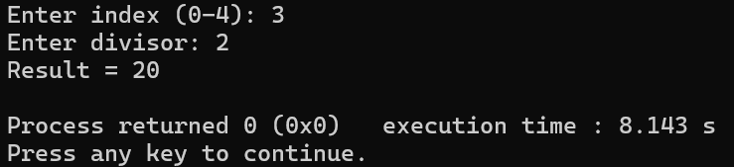

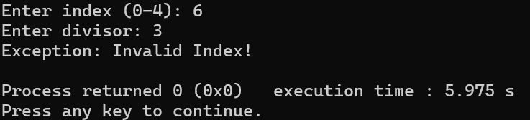

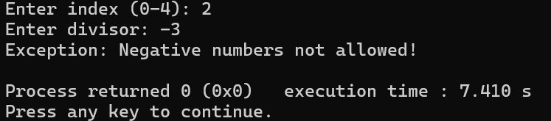

->TEMPLATES AND STL:

1.SWAPPING:

#include<iostream>
using namespace std;

template <class T>
void swapValues(T &a, T &b)
{
T temp = a;
a = b;
b = temp;
}

int main()
{
int x = 10, y = 20;
swapValues(x, y);
cout<<"After swap: "<<x<<" "<<y<<endl;

float a = 1.5, b = 2.5;
swapValues(a, b);
cout<<"After swap: "<<a<<" "<<b<<endl;

return 0;
}

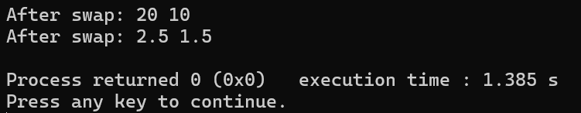

2.MAXIMUM OF TWO VALUES:

#include<iostream>
using namespace std;

template <class T>
T findMax(T a, T b)
{
return (a > b) ? a : b;
}

int main()
{
cout<<"Max (int): "<<findMax(10, 20)<<endl;
cout<<"Max (float): "<<findMax(3.5, 2.1)<<endl;

return 0;
}

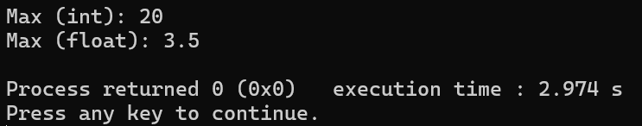

3.CALCULATOR:

#include<iostream>
using namespace std;

template <class T>
class Calculator
{
T a, b;
public:
Calculator(T x, T y)
{
a = x;
b = y;
}

void add()
{
cout<<"Addition: "<<a + b<<endl;
}

void multiply()
{
cout<<"Multiplication: "<<a * b<<endl;
}
};

int main()
{
Calculator<int> c1(10, 5);
c1.add();
c1.multiply();

Calculator<float> c2(2.5, 3.5);
c2.add();
c2.multiply();

return 0;
}

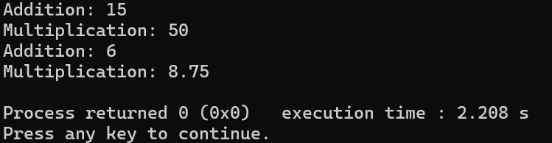

4.SUM OF ARRAY:

#include<iostream>
using namespace std;

template <class T>
T sumArray(T arr[], int size)
{
T sum = 0;
for(int i = 0; i < size; i++)
sum += arr[i];
return sum;
}

int main()
{
int a[] = {1,2,3,4};
float b[] = {1.1,2.2,3.3};

cout<<"Sum int: "<<sumArray(a,4)<<endl;
cout<<"Sum float: "<<sumArray(b,3)<<endl;

return 0;
}

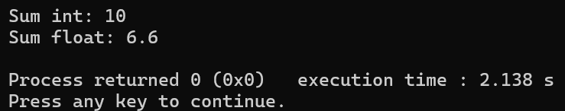

5.VECTOR OPERATIONS:

#include<iostream>
#include<vector>
using namespace std;

int main()
{
vector<int> v;
int n, x;

cout<<"Enter number of elements: ";
cin>>n;

cout<<"Enter elements: ";
for(int i=0;i<n;i++)
{
cin>>x;
v.push_back(x);
}

cout<<"Elements: ";
for(int i=0;i<v.size();i++)
cout<<v[i]<<" ";

cout<<"\nSize: "<<v.size()<<endl;

return 0;
}

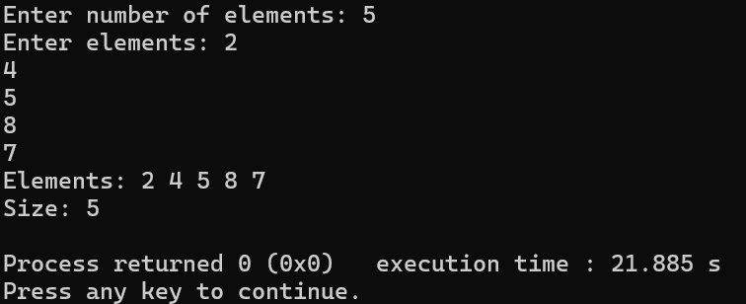

6.LIST OPERATIONS:

#include<iostream>
#include<list>
using namespace std;

int main()
{
list<int> l;

l.push_back(10);
l.push_back(20);
l.push_front(5);

cout<<"List elements: ";
for(int x : l)
cout<<x<<" ";

l.pop_front();

cout<<"\nAfter removing front: ";
for(int x : l)
cout<<x<<" ";

return 0;
}

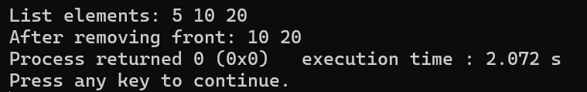

7.QUEUE:

#include<iostream>
#include<queue>
using namespace std;

int main()
{
queue<int> q;
int choice, val;

while(true)
{
cout<<"\n1.Add Customer\n2.Serve Customer\n3.Display\n4.Exit\n";
cout<<"Enter choice: ";
cin>>choice;

switch(choice)
{
case 1:
cout<<"Enter customer ID: ";
cin>>val;
q.push(val);
cout<<"Customer added!"<<endl;
break;

case 2:
if(q.empty())
{
cout<<"No customers in queue!"<<endl;
}
else
{
cout<<"Serving customer: "<<q.front()<<endl;
q.pop();
}
break;

case 3:
if(q.empty())
{
cout<<"Queue is empty!"<<endl;
}
else
{
queue<int> temp = q; // copy to display
cout<<"Customers in queue: ";
while(!temp.empty())
{
cout<<temp.front()<<" ";
temp.pop();
}
cout<<endl;
}
break;

case 4:
return 0;

default:
cout<<"Invalid choice!"<<endl;
}
}
}

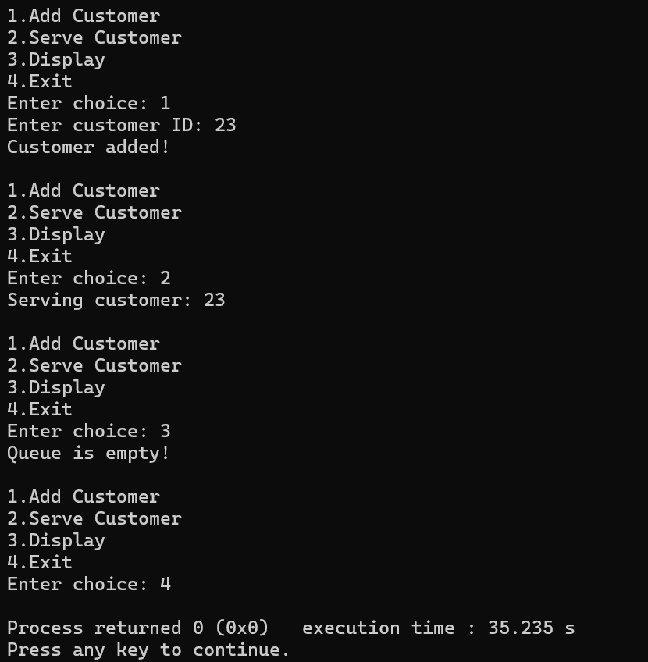

8.STL CODE:

#include<iostream>
#include<vector>
#include<list>
#include<queue>
using namespace std;

class ShoppingSystem
{
vector<int> cart; // store items
list<string> history; // store actions
queue<int> orders; // order processing

public:
void addItem(int x)
{
cart.push_back(x);
history.push_back("Item added");
cout<<"Item added to cart!"<<endl;
}

void removeItem()
{
if(cart.empty())
{
cout<<"Cart is empty!"<<endl;
return;
}

cout<<"Removed item: "<<cart.back()<<endl;
cart.pop_back();
history.push_back("Item removed");
}

void placeOrder()
{
if(cart.empty())
{
cout<<"Cart is empty! Cannot place order."<<endl;
return;
}

for(int x : cart)
orders.push(x);

cart.clear();
history.push_back("Order placed");

cout<<"Order placed successfully!"<<endl;
}

void processOrder()
{
if(orders.empty())
{
cout<<"No orders to process!"<<endl;
return;
}

cout<<"Processing item: "<<orders.front()<<endl;
orders.pop();
history.push_back("Order processed");
}

void displayCart()
{
if(cart.empty())
{
cout<<"Cart is empty!"<<endl;
return;
}

cout<<"Cart items: ";
for(int x : cart)
cout<<x<<" ";
cout<<endl;
}

void displayHistory()
{
if(history.empty())
{
cout<<"No history!"<<endl;
return;
}

cout<<"Recent Activities:\n";
for(string s : history)
cout<<s<<endl;
}
};

int main()
{
ShoppingSystem s;
int choice, val;

while(true)
{
cout<<"\n1.Add Item\n2.Remove Item\n3.Display Cart\n4.Place Order\n5.Process Order\n6.History\n7.Exit\n";
cout<<"Enter choice: ";
cin>>choice;

switch(choice)
{
case 1:
cout<<"Enter item: ";
cin>>val;
s.addItem(val);
break;

case 2:
s.removeItem();
break;

case 3:
s.displayCart();
break;

case 4:
s.placeOrder();
break;

case 5:
s.processOrder();
break;

case 6:
s.displayHistory();
break;

case 7:
return 0;

default:
cout<<"Invalid choice!"<<endl;
}
}
}

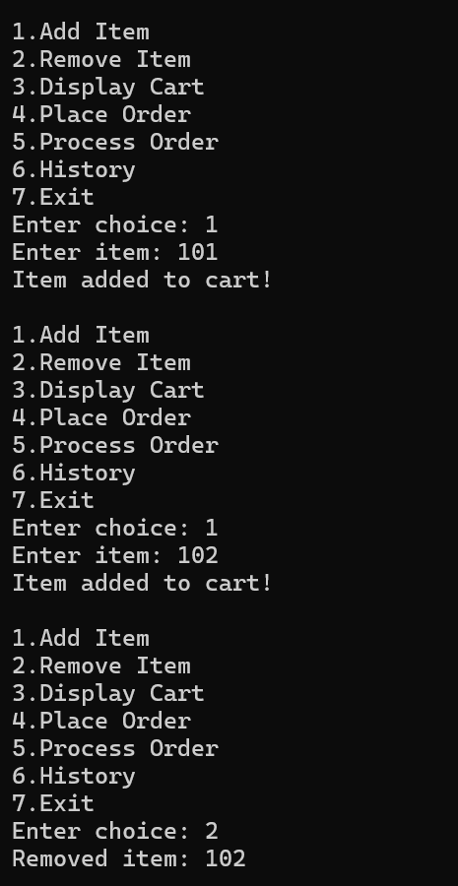
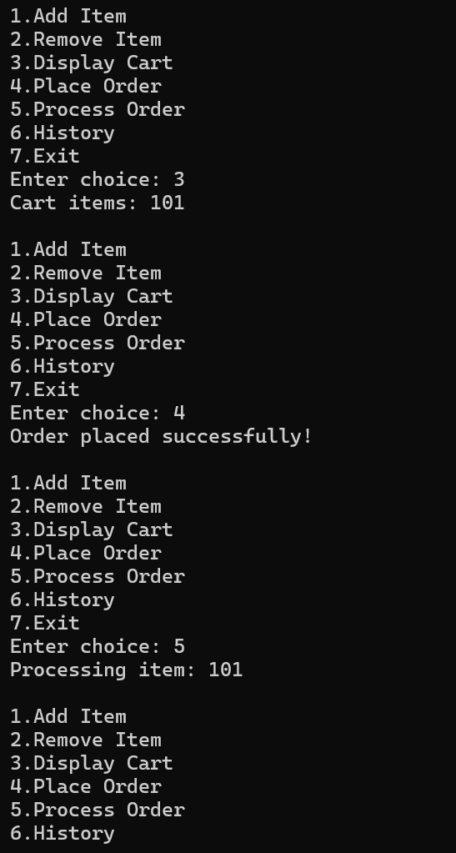
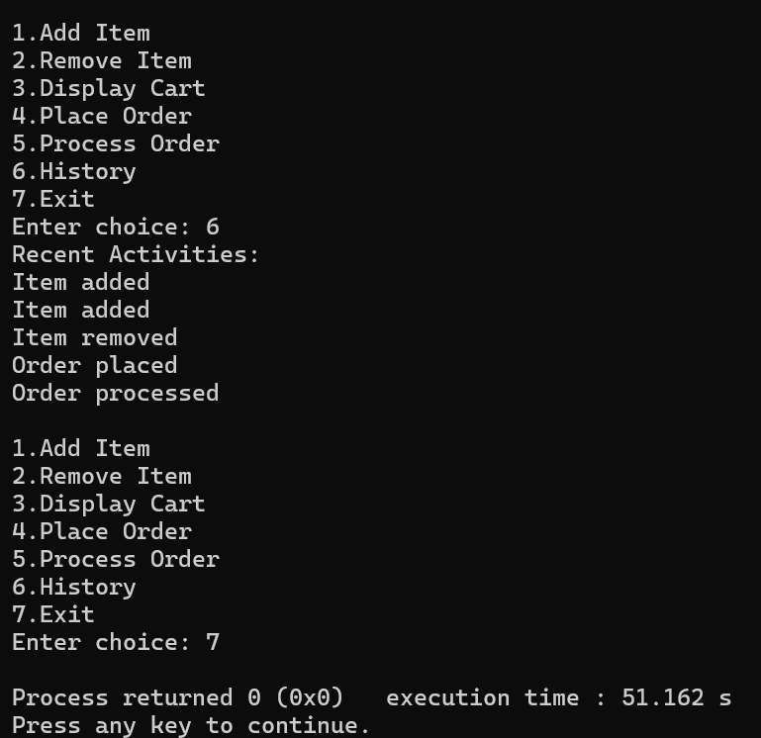

->POINTERS IN CLASSES:

1.POINTER TO OBJECT:

#include<iostream>
using namespace std;

class Student
{
public:
int age;
};

int main()
{
Student s;
Student *ptr = &s;

ptr->age = 20;

cout<<"Age: "<<ptr->age<<endl;

return 0;
}

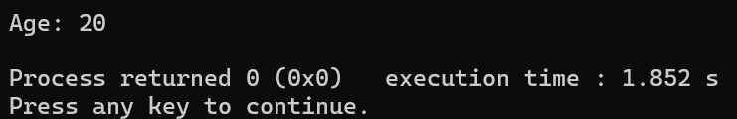

2.ACCESS CLASS MEMBERS:

#include<iostream>
using namespace std;

class Rectangle
{
int length, breadth;

public:
void set(int l, int b)
{
length = l;
breadth = b;
}

int area()
{
return length * breadth;
}
};

int main()
{
Rectangle r;
Rectangle *ptr = &r;

ptr->set(5, 4);
cout<<"Area: "<<ptr->area()<<endl;

return 0;
}

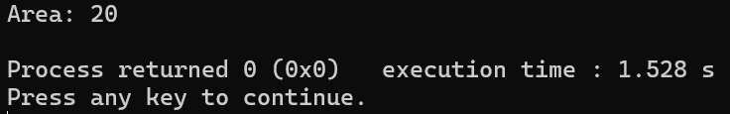

3.ARRAY OF OBJECTS:

#include<iostream>
using namespace std;

class Student
{
public:
int marks;
};

int main()
{
Student *ptr = new Student[3];

for(int i=0;i<3;i++)
{
cout<<"Enter marks: ";
cin>>ptr[i].marks;
}

cout<<"Marks:\n";
for(int i=0;i<3;i++)
cout<<ptr[i].marks<<" ";

delete[] ptr;

return 0;
}

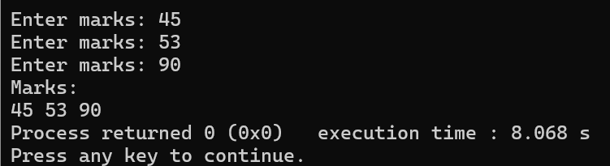

4.SWAPPING:

#include<iostream>
using namespace std;

class Numbers
{
int *a, *b;

public:
Numbers()
{
a = new int;
b = new int;
}

void input()
{
cout<<"Enter two numbers: ";
cin>>*a>>*b;
}

void sum()
{
cout<<"Sum: "<<(*a + *b)<<endl;
}

void swapValues()
{
int temp = *a;
*a = *b;
*b = temp;
cout<<"Values swapped!"<<endl;
}

void display()
{
cout<<"a = "<<*a<<" b = "<<*b<<endl;
}
};

int main()
{
Numbers n;

n.input();
n.display();
n.sum();

n.swapValues();
n.display();

return 0;
}

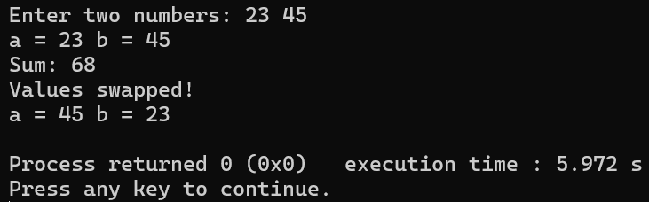

5.BANK SYSTEM:

#include<iostream>
using namespace std;

class Bank
{
int balance;

public:
Bank(int b)
{
balance = b;
}

void deposit(int amt)
{
balance += amt;
cout<<"Balance: "<<balance<<endl;
}

void withdraw(int amt)
{
if(amt > balance)
{
cout<<"Insufficient balance!"<<endl;
return;
}
balance -= amt;
cout<<"Balance: "<<balance<<endl;
}
};

int main()
{
Bank *b = new Bank(1000);

b->deposit(500);
b->withdraw(200);

delete b;

return 0;
}

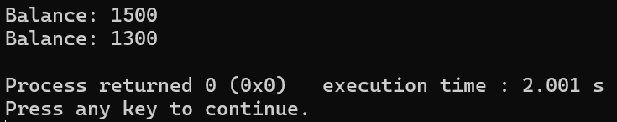

6.EMPLOYEE MANAGEMENT:

#include<iostream>
using namespace std;

class Employee
{
int id;
public:
void input()
{
cout<<"Enter ID: ";
cin>>id;
}

void display()
{
cout<<"ID: "<<id<<endl;
}
};

int main()
{
Employee *emp[3];

for(int i=0;i<3;i++)
{
emp[i] = new Employee;
emp[i]->input();
}

cout<<"Employee Details:\n";
for(int i=0;i<3;i++)
emp[i]->display();

return 0;
}

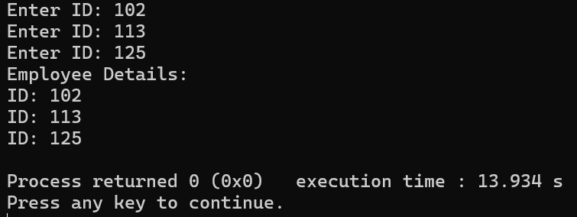

7.DYNAMIC MEMORY:

#include<iostream>
using namespace std;

class Array
{
int *arr;
int size;

public:
void create(int s)
{
size = s;
arr = new int[size];

cout<<"Enter elements: ";
for(int i=0;i<size;i++)
cin>>arr[i];
}

void display()
{
for(int i=0;i<size;i++)
cout<<arr[i]<<" ";
cout<<endl;
}

~Array()
{
delete[] arr;
}
};

int main()
{
Array a;
int choice, n;

while(true)
{
cout<<"\n1.Create\n2.Display\n3.Exit\n";
cin>>choice;

switch(choice)
{
case 1:
cout<<"Enter size: ";
cin>>n;
a.create(n);
break;
case 2:
a.display();
break;
case 3:
return 0;
}
}
}

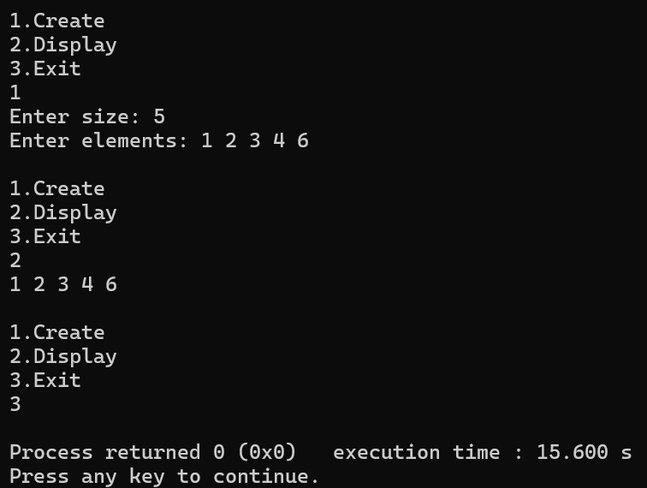

8.LIBRARY SYSTEM:

#include<iostream>
using namespace std;

class Library
{
int *books;
int size;
int issued;

public:
Library(int s)
{
size = s;
books = new int[size];
issued = 0;

for(int i=0;i<size;i++)
books[i] = 1; // 1 = available
}

void issueBook()
{
for(int i=0;i<size;i++)
{
if(books[i] == 1)
{
books[i] = 0;
issued++;
cout<<"Book issued!"<<endl;
return;
}
}
cout<<"No books available!"<<endl;
}

void returnBook()
{
for(int i=0;i<size;i++)
{
if(books[i] == 0)
{
books[i] = 1;
issued--;
cout<<"Book returned!"<<endl;
return;
}
}
cout<<"No books to return!"<<endl;
}

void display()
{
cout<<"Available books: "<<(size - issued)<<endl;
}

~Library()
{
delete[] books;
}
};

int main()
{
Library l(5);
int choice;

while(true)
{
cout<<"\n1.Issue Book\n2.Return Book\n3.Display\n4.Exit\n";
cin>>choice;

switch(choice)
{
case 1: l.issueBook(); break;
case 2: l.returnBook(); break;
case 3: l.display(); break;
case 4: return 0;
}
}
}

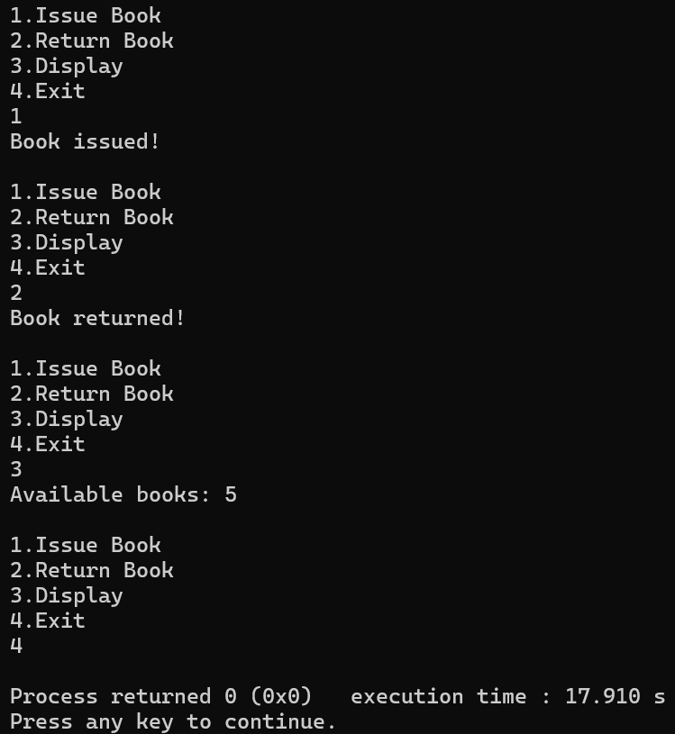

->FILE HANDLING:

1.WRITE TO A FILE:

#include<iostream>
#include<fstream>
using namespace std;

int main()
{
ofstream fout("data.txt");

fout<<"Hello World!"<<endl;
fout<<"File Handling in C++"<<endl;

fout.close();
cout<<"Data written to file."<<endl;

return 0;
}

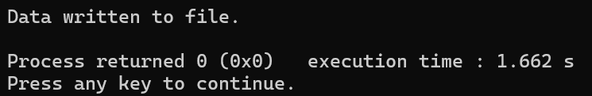

2.READ FROM A FILE:

#include<iostream>
#include<fstream>
using namespace std;

int main()
{
ifstream fin("data.txt");
string line;

while(getline(fin, line))
{
cout<<line<<endl;
}

fin.close();
return 0;
}

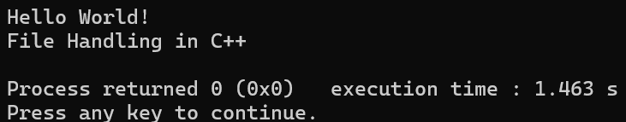

3.APPEND TO A FILE:

#include<iostream>
#include<fstream>
using namespace std;

int main()
{
ofstream fout("data.txt", ios::app);

fout<<"Appending new line!"<<endl;

fout.close();
cout<<"Data appended."<<endl;

return 0;
}

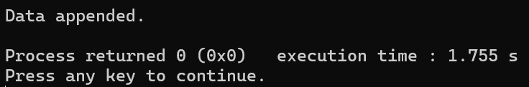

4.COUNT WORDS IN A FILE:

#include<iostream>
#include<fstream>
using namespace std;

int main()
{
ifstream fin("data.txt");
string word;
int count = 0;

while(fin >> word)
{
count++;
}

cout<<"Total words: "<<count<<endl;

fin.close();
return 0;
}

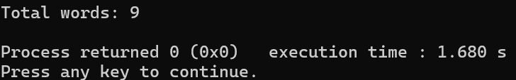

5.STUDENT SYSTEM:

#include<iostream>
#include<fstream>
using namespace std;

class Student
{
int id;
string name;

public:
void input()
{
cout<<"Enter ID and Name: ";
cin>>id>>name;
}

void write()
{
ofstream fout("student.txt", ios::app);
fout<<id<<" "<<name<<endl;
fout.close();

cout<<"Record added successfully!"<<endl;
}

void display()
{
ifstream fin("student.txt");
int i;
string n;

cout<<"\nRecords:\n";
while(fin>>i>>n)
{
cout<<i<<" "<<n<<endl;
}

fin.close();
}
};

int main()
{
ofstream clearFile("student.txt");
clearFile.close();

Student s;
int choice;

while(true)
{
cout<<"\n1.Add Record\n2.Display\n3.Exit\n";
cout<<"Enter choice: ";
cin>>choice;

switch(choice)
{
case 1:
s.input();
s.write();
break;

case 2:
s.display();
break;

case 3:
return 0;

default:
cout<<"Invalid choice!"<<endl;
}
}
}

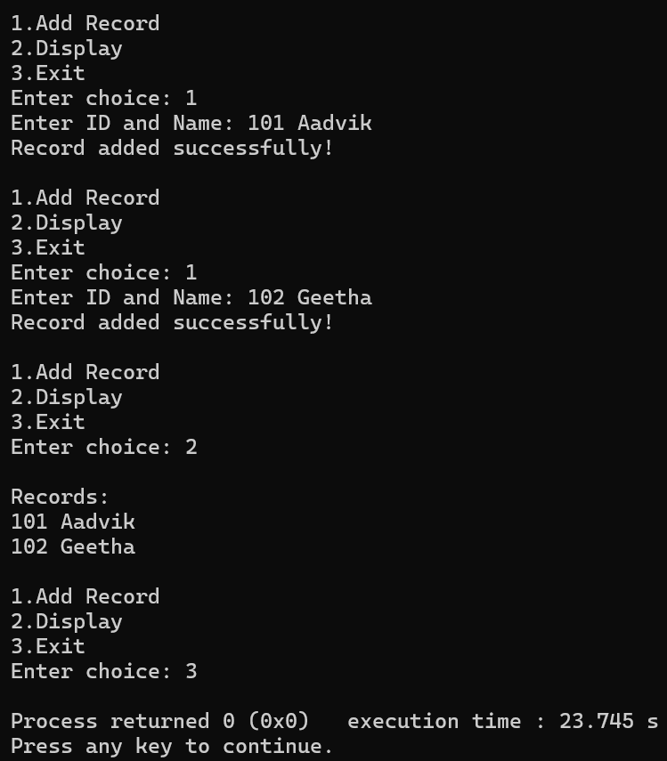

6.COPY ONE FILE TO ANOTHER:

#include<iostream>
#include<fstream>
using namespace std;

int main()
{
ifstream fin("data.txt");
ofstream fout("copy.txt");

string line;

while(getline(fin, line))
{
fout<<line<<endl;
}

cout<<"File copied successfully!"<<endl;

fin.close();
fout.close();

return 0;
}

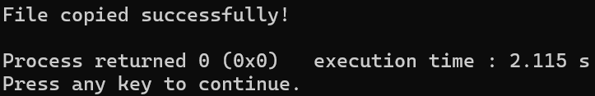

7.SEARCH WORD IN A FILE:

#include<iostream>
#include<fstream>
using namespace std;

int main()
{
ifstream fin("data.txt");
string word, target;
bool found = false;

cout<<"Enter word to search: ";
cin>>target;

while(fin >> word)
{
if(word == target)
{
found = true;
break;
}
}

if(found)
cout<<"Word found!"<<endl;
else
cout<<"Word not found!"<<endl;

fin.close();
return 0;
}

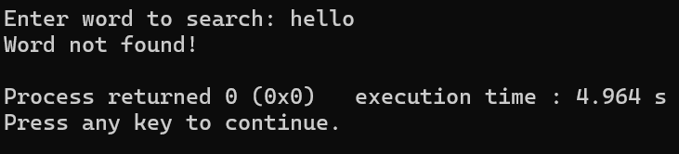

8.LIBRARY MANAGEMENT:

#include<iostream>
#include<fstream>
using namespace std;

class Library
{
public:
void addBook()
{
ofstream fout("library.txt", ios::app);
string name;

cout<<"Enter book name: ";
cin>>name;

fout<<name<<endl;
fout.close();

cout<<"Book added!"<<endl;
}

void displayBooks()
{
ifstream fin("library.txt");
string name;

cout<<"Books in Library:\n";
while(fin>>name)
{
cout<<name<<endl;
}

fin.close();
}

void searchBook()
{
ifstream fin("library.txt");
string name, target;
bool found = false;

cout<<"Enter book to search: ";
cin>>target;

while(fin>>name)
{
if(name == target)
{
found = true;
break;
}
}

if(found)
cout<<"Book found!"<<endl;
else
cout<<"Book not found!"<<endl;

fin.close();
}
};

int main()
{
ofstream clearFile("library.txt");
clearFile.close();

Library l;
int choice;

while(true)
{
cout<<"\n1.Add Book\n2.Display\n3.Search\n4.Exit\n";
cout<<"Enter choice: ";
cin>>choice;

switch(choice)
{
case 1: l.addBook(); break;
case 2: l.displayBooks(); break;
case 3: l.searchBook(); break;
case 4: return 0;
default: cout<<"Invalid choice!"<<endl;
}
}
}

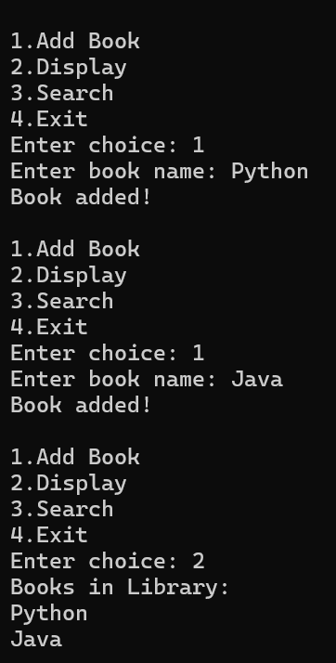

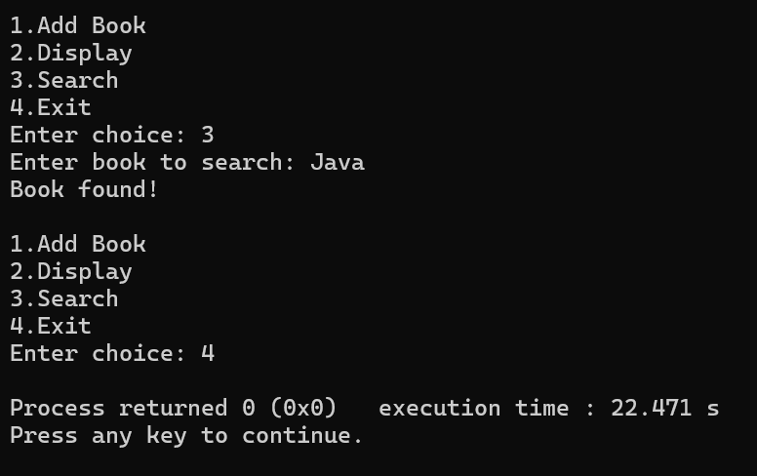

->FORMATTED I/O:

1.STUDENT DETAILS:

#include<iostream>
#include<iomanip>
using namespace std;

int main()
{
cout<<setw(10)<<"Name"
<<setw(10)<<"Marks"
<<setw(10)<<"Grade"<<endl;

cout<<setw(10)<<"John"
<<setw(10)<<85
<<setw(10)<<"A"<<endl;

cout<<setw(10)<<"Mary"
<<setw(10)<<78
<<setw(10)<<"B"<<endl;

return 0;
}

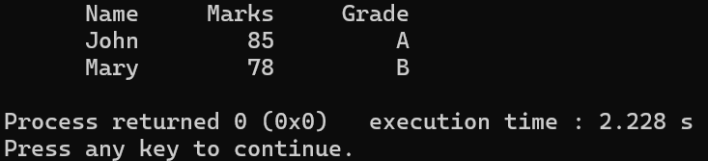

2.CURRENCY FORMATTING:

#include<iostream>
#include<iomanip>
using namespace std;

int main()
{
float amount;

cout<<"Enter amount: ";
cin>>amount;

cout<<"Formatted Amount: ";
cout<<fixed<<setprecision(2)<<amount<<endl;

return 0;
}

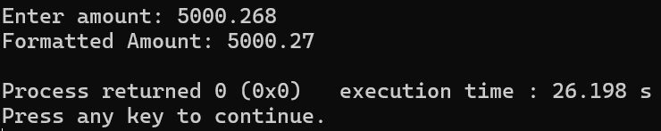

3.ALIGNMENT SYSTEM:

#include<iostream>
#include<iomanip>
using namespace std;

int main()
{
cout<<left<<setw(15)<<"Product"
<<right<<setw(10)<<"Price"<<endl;

cout<<left<<setw(15)<<"Pen"
<<right<<setw(10)<<20<<endl;

cout<<left<<setw(15)<<"Notebook"
<<right<<setw(10)<<50<<endl;

return 0;
}

